Quant I: Fall 2013
Prof. Patrick Egan

Tabular and Graphical Methods
for Displaying and Summarizing Relationships Between Two Variables
(along with some other related remarks)

I. DISPLAYING the Relationship

a. Crosstab(ulation)s:

• Y is typically displayed by row; X by column

. tab faminc educyears

Household |
Income, | Years of Education
2004 | 0 2.5 5.5 7.5 9 10 11 11.5 | Total
-----------+----------------------------------------------------------------------------------------+----------
2500 | 2 0 4 7 4 12 11 2 | 134
6250 | 2 6 5 6 7 13 9 0 | 112
8250 | 0 3 4 16 5 8 9 2 | 120
11500 | 0 2 5 10 11 9 16 5 | 165
13750 | 0 1 3 10 13 7 8 0 | 140
17500 | 1 5 6 14 17 21 14 6 | 232
22500 | 1 2 7 15 21 14 19 5 | 326
27500 | 1 1 4 16 14 16 21 3 | 330
32500 | 4 2 8 9 19 20 11 3 | 340
37500 | 2 3 4 9 12 12 17 3 | 324
45000 | 2 1 6 12 20 16 22 14 | 551
55000 | 3 4 2 9 12 20 17 8 | 501
67500 | 0 0 0 8 12 14 11 13 | 621
87500 | 0 0 1 8 16 19 21 2 | 634
125000 | 0 0 1 6 10 13 16 2 | 470
-----------+----------------------------------------------------------------------------------------+----------
Total | 18 30 60 155 193 214 222 68 | 5,000

Household |
Income, | Years of Education
2004 | 12 13 14 16 18 22 | Total
-----------+------------------------------------------------------------------+----------
2500 | 40 27 7 13 5 0 | 134
6250 | 31 27 1 4 1 0 | 112
8250 | 48 9 6 9 1 0 | 120
11500 | 65 22 9 9 2 0 | 165
13750 | 62 24 7 5 0 0 | 140
17500 | 105 20 6 16 1 0 | 232
22500 | 120 54 22 36 9 1 | 326
27500 | 124 63 28 34 5 0 | 330
32500 | 115 62 28 46 12 1 | 340
37500 | 131 56 25 36 11 3 | 324
45000 | 185 96 52 81 40 4 | 551
55000 | 150 110 47 84 32 3 | 501
67500 | 185 128 65 131 50 4 | 621
87500 | 140 116 53 155 93 10 | 634
125000 | 67 85 47 138 68 17 | 470
-----------+------------------------------------------------------------------+----------
Total | 1,568 899 403 797 330 43 | 5,000

• Often more informative to provide column percents. Note that convention is typically to provide column, not row, percents. Include 100s at the bottom so reader can quickly see that columns add up to 100:

. tab faminc educyears, col nofr

Household |
Income, | Years of Education
2004 | 0 2.5 5.5 7.5 9 10 11 11.5 | Total
-----------+----------------------------------------------------------------------------------------+----------
2500 | 11.11 0.00 6.67 4.52 2.07 5.61 4.95 2.94 | 2.68
6250 | 11.11 20.00 8.33 3.87 3.63 6.07 4.05 0.00 | 2.24
8250 | 0.00 10.00 6.67 10.32 2.59 3.74 4.05 2.94 | 2.40
11500 | 0.00 6.67 8.33 6.45 5.70 4.21 7.21 7.35 | 3.30
13750 | 0.00 3.33 5.00 6.45 6.74 3.27 3.60 0.00 | 2.80
17500 | 5.56 16.67 10.00 9.03 8.81 9.81 6.31 8.82 | 4.64
22500 | 5.56 6.67 11.67 9.68 10.88 6.54 8.56 7.35 | 6.52
27500 | 5.56 3.33 6.67 10.32 7.25 7.48 9.46 4.41 | 6.60
32500 | 22.22 6.67 13.33 5.81 9.84 9.35 4.95 4.41 | 6.80
37500 | 11.11 10.00 6.67 5.81 6.22 5.61 7.66 4.41 | 6.48
45000 | 11.11 3.33 10.00 7.74 10.36 7.48 9.91 20.59 | 11.02
55000 | 16.67 13.33 3.33 5.81 6.22 9.35 7.66 11.76 | 10.02
67500 | 0.00 0.00 0.00 5.16 6.22 6.54 4.95 19.12 | 12.42
87500 | 0.00 0.00 1.67 5.16 8.29 8.88 9.46 2.94 | 12.68
125000 | 0.00 0.00 1.67 3.87 5.18 6.07 7.21 2.94 | 9.40
-----------+----------------------------------------------------------------------------------------+----------
Total | 100.00 100.00 100.00 100.00 100.00 100.00 100.00 100.00 | 100.00

Household |
Income, | Years of Education
2004 | 12 13 14 16 18 22 | Total
-----------+------------------------------------------------------------------+----------
2500 | 2.55 3.00 1.74 1.63 1.52 0.00 | 2.68
6250 | 1.98 3.00 0.25 0.50 0.30 0.00 | 2.24
8250 | 3.06 1.00 1.49 1.13 0.30 0.00 | 2.40
11500 | 4.15 2.45 2.23 1.13 0.61 0.00 | 3.30
13750 | 3.95 2.67 1.74 0.63 0.00 0.00 | 2.80
17500 | 6.70 2.22 1.49 2.01 0.30 0.00 | 4.64
22500 | 7.65 6.01 5.46 4.52 2.73 2.33 | 6.52
27500 | 7.91 7.01 6.95 4.27 1.52 0.00 | 6.60
32500 | 7.33 6.90 6.95 5.77 3.64 2.33 | 6.80
37500 | 8.35 6.23 6.20 4.52 3.33 6.98 | 6.48
45000 | 11.80 10.68 12.90 10.16 12.12 9.30 | 11.02
55000 | 9.57 12.24 11.66 10.54 9.70 6.98 | 10.02
67500 | 11.80 14.24 16.13 16.44 15.15 9.30 | 12.42
87500 | 8.93 12.90 13.15 19.45 28.18 23.26 | 12.68
125000 | 4.27 9.45 11.66 17.31 20.61 39.53 | 9.40
-----------+------------------------------------------------------------------+----------
Total | 100.00 100.00 100.00 100.00 100.00 100.00 | 100.00

• Lots of categories of both X and Y, so maybe you recode:

. gen educ_rc = educyears

. recode educ_rc (0/7.5 =1) (9/11.5=2) (12=3) (13/14=4) (16=5) (18/22=6)
(educ_rc: 5000 changes made)

. label def educ_rc 1 "< 8th grade" 2 "< H.S" 3 "HS Diploma" 4 "Some college" 5 "B.A." 6 "Post-grad"

. label values educ_rc educ_rc

. tab educ_rc

educ_rc | Freq. Percent Cum.
-------------+-----------------------------------
< 8th grade | 263 5.26 5.26
< H.S | 697 13.94 19.20
HS Diploma | 1,568 31.36 50.56
Some college | 1,302 26.04 76.60
B.A. | 797 15.94 92.54
Post-grad | 373 7.46 100.00
-------------+-----------------------------------
Total | 5,000 100.00

. gen faminc_rc = famincome

. recode faminc_rc (0/20000 = 1) (21000/40000=2) (41000/70000=3) (71000/max=4)
(faminc_rc: 5000 changes made)

. label def faminc_rc 1 "<$20K" 2 "$21-$40K" 3 "$41-$70K" 4 ">$70K"

. label values faminc_rc faminc_rc

. tab faminc_rc

faminc_rc | Freq. Percent Cum.
------------+-----------------------------------
<$20K | 903 18.06 18.06
$21-$40K | 1,320 26.40 44.46
$41-$70K | 1,673 33.46 77.92
>$70K | 1,104 22.08 100.00
------------+-----------------------------------
Total | 5,000 100.00

• This crosstab is now easier to read (though of course we’ve lost some information).

• To detect a relationship between X and Y, see how the column percents change within rows (note how it’s now easier to do this than it was on the bigger crosstab earlier):

. tab faminc_rc educ_rc, col nofr

| educ_rc
faminc_rc | < 8th gra < H.S HS Diplom Some coll B.A. Post-grad | Total
-----------+------------------------------------------------------------------+----------
<$20K | 42.59 29.99 22.39 12.67 7.03 2.68 | 18.06
$21-$40K | 33.46 30.13 31.25 25.96 19.07 11.26 | 26.40
$41-$70K | 17.87 25.68 33.16 38.25 37.14 35.66 | 33.46
>$70K | 6.08 14.20 13.20 23.12 36.76 50.40 | 22.08
-----------+------------------------------------------------------------------+----------
Total | 100.00 100.00 100.00 100.00 100.00 100.00 | 100.00

b. Scatterplots (both variables at interval-level or higher):

. twoway (scatter famincome educyears)

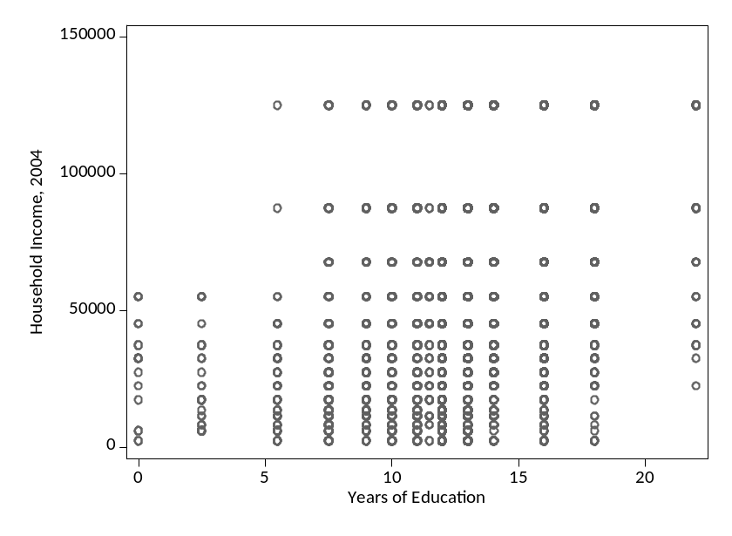

Not very informative, so let’s jitter, adding noise to each marker that is equivalent to 5% of area of graph:

twoway (scatter famincome educyears, jitter(5))

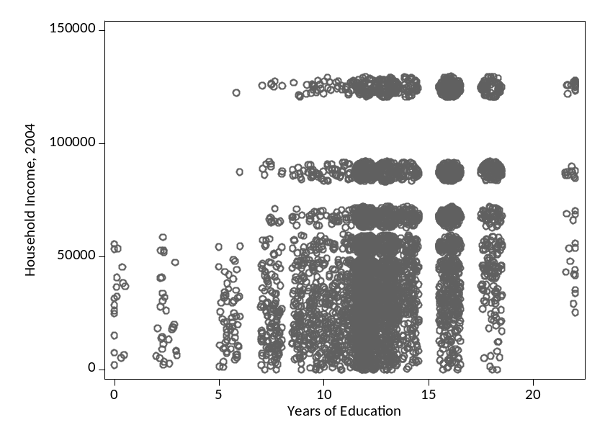

Still not so good, let’s try 20%:

twoway (scatter famincome educyears, jitter(20))

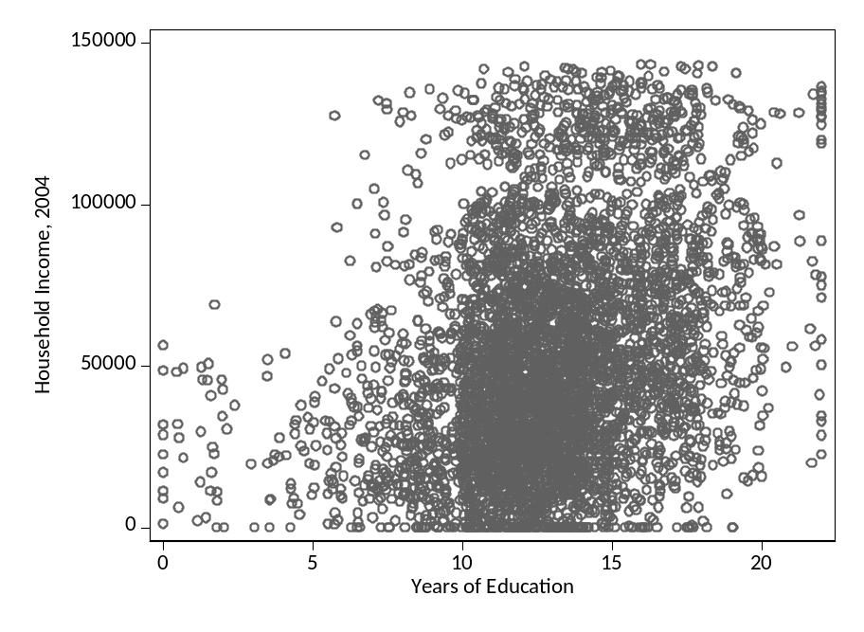

c. Boxplots (appropriate when Y is at interval-level, and X has few categories and/or is less than interval level):

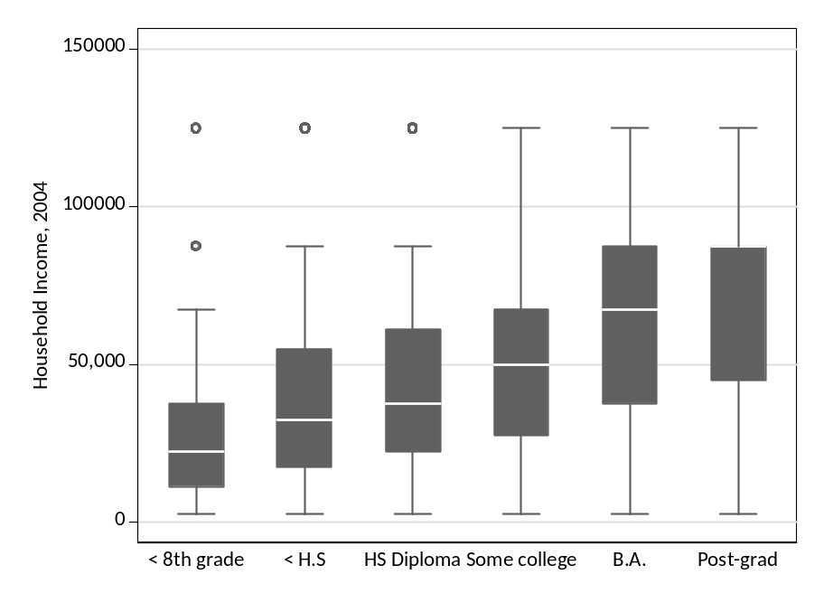

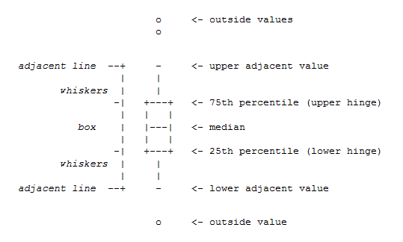
OK, but what’s an “adjacent value”? From Stata manual:

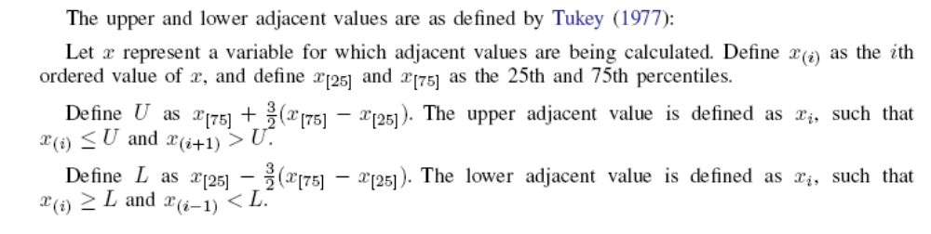

d. “Binning out” X and then displaying the mean Y in each “bin” of X. Good when X is continuous/takes on many values but Y is dichotomous. From Egan & Mullin (2012):

. sum getwarm01, d

Belief that there is "solid evidence" for global
warming (0 = No, 1 = Yes)
-------------------------------------------------------------
Percentiles Smallest
1% 0 0
5% 0 0
10% 0 0 Obs 7224
25% 0 0 Sum of Wgt. 7224

50% 1 Mean .732835
Largest Std. Dev. .4425099
75% 1 1
90% 1 1 Variance .195815
95% 1 1 Skewness -1.052411
99% 1 1 Kurtosis 2.107569

. sum temp, d

Mean departure from normal daily local
temperature, week before survey
-------------------------------------------------------------
Percentiles Smallest
1% -7 -17.42857
5% -4.285714 -15.14286
10% -2.714286 -14.28571 Obs 7971
25% -.1428571 -13 Sum of Wgt. 7971

50% 2.571429 Mean 3.536448
Largest Std. Dev. 5.728437
75% 6.285714 37.57143
90% 11.57143 37.57143 Variance 32.815
95% 14.28571 37.71429 Skewness .9993781
99% 18.28572 40.28571 Kurtosis 5.503608

Here, a scatterplot is virtually worthless:

twoway scatter getwarm01 temp, aspect(1)

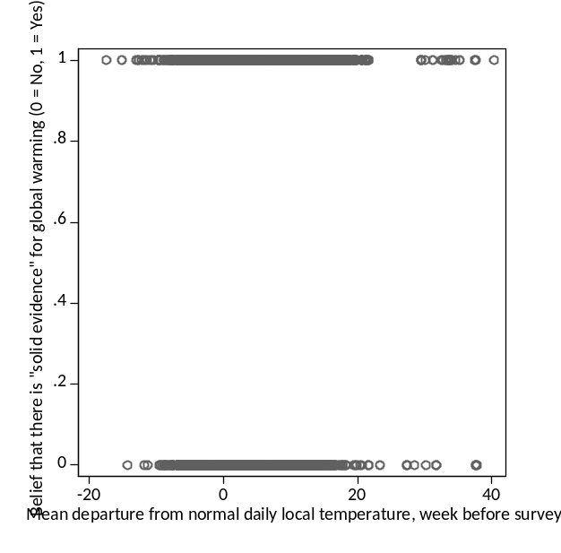

So we “bin out” our X (temp), creating equal-sized bins of temp. Do-file below does this for any x (called ‘x-var’ in the do-file)

*this do-file creates a user-specified total # of "bins" of the variable xvar, each with an approximately equal number of observations. the bins are found in a new variable named the (name of your xvar) + suffix "bin".

*user fills in following three local macros:
local xvar xvargoeshere
local yvar yvargoeshere
local bins numberofbinsdesiredgoeshere

local binsminus1 = `bins'-1
local binsminus2 = `bins'-2

_pctile `xvar', n(`bins')

gen `xvar'bin = .

replace `xvar'bin = 0 if `xvar' <= `r(r1)'

forvalues i = 1(1)`binsminus2' {
local j = `i'+1
replace `xvar'bin = `r(r`i')' if `xvar' > `r(r`i')' & `xvar' <= `r(r`j')'
}

replace `xvar'bin = `r(r`binsminus1')' if `xvar' > `r(r`binsminus1')'

replace `xvar'bin = . if `xvar'==.

save, replace

*now if you wanted to create the dataset you'd use to create the graph (where means of yvar are plotted against the bin values), you might do the following:

collapse (mean) `yvar', by(`xvar'bin race)

save bindata, replace

twoway (scatter `yvar' `xvar'bin) (lowess `yvar' `xvar'bin)

*etc.
Here, I’ve created 50 bins of temp. Note that because of lumpiness of data they don’t all have exactly equal numbers of obs. Not a big deal for our purposes.

tempbin | Freq. Percent Cum.
------------+-----------------------------------
-6.142857 | 165 2.07 2.07
-4.714286 | 184 2.31 4.38
-3.857143 | 90 1.13 5.51
-3.285714 | 242 3.04 8.54
-2.714286 | 94 1.18 9.72
-2.285714 | 153 1.92 11.64
-1.857143 | 149 1.87 13.51
-1.428571 | 256 3.21 16.72
-1 | 98 1.23 17.95
-.8571429 | 174 2.18 20.14
-.5714286 | 172 2.16 22.29
-.2857143 | 205 2.57 24.87
0 | 277 3.48 28.34
.1428571 | 197 2.47 30.81
.4285714 | 106 1.33 32.14
.5714286 | 232 2.91 35.05
.8571429 | 126 1.58 36.63
1 | 108 1.35 37.99
1.271429 | 206 2.58 40.57
1.428571 | 176 2.21 42.78
1.714286 | 121 1.52 44.30
1.857143 | 217 2.72 47.02
2.142857 | 99 1.24 48.26
2.285714 | 97 1.22 49.48
2.571429 | 286 3.59 53.07
2.857143 | 91 1.14 54.21
3 | 164 2.06 56.27
3.285714 | 112 1.41 57.67
3.571429 | 93 1.17 58.84
3.714286 | 254 3.19 62.02
4 | 182 2.28 64.31
4.285714 | 181 2.27 66.58
4.714286 | 140 1.76 68.34
5 | 133 1.67 70.00
5.285714 | 198 2.48 72.49
5.714286 | 125 1.57 74.06
6 | 189 2.37 76.43
6.571429 | 126 1.58 78.01
7.033163 | 168 2.11 80.12
7.857143 | 157 1.97 82.09
8.571428 | 187 2.35 84.43
9.571428 | 134 1.68 86.11
10 | 134 1.68 87.79
10.71429 | 188 2.36 90.15
11.57143 | 180 2.26 92.41
12.57143 | 130 1.63 94.04
13.42857 | 176 2.21 96.25
15 | 156 1.96 98.21
16.57143 | 143 1.79 100.00
------------+-----------------------------------
Total | 7,971 100.00

Now generate new file:

collapse (mean) getwarm01, by (tempbin)
twoway scatter getwarm01 tempbin, aspect(1)

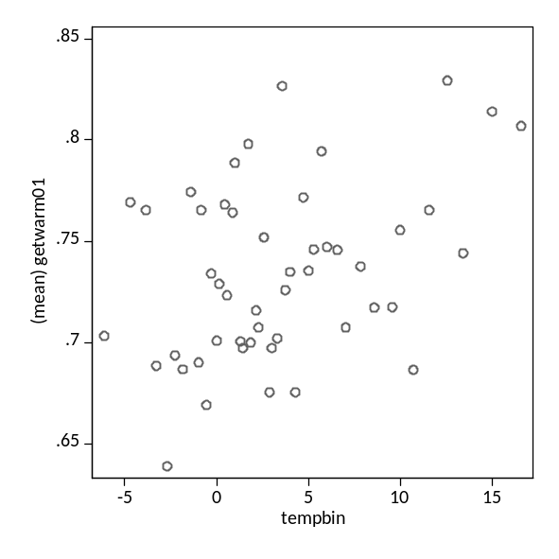

So much better, right?

One other thing: note that I use the option aspect(1). This forces Stata to produce a graph with aspect ratio (i.e. ratio of height:width) of 1. Otherwise, Stata’s default is the “golden ratio,” which is approx 1:1.6. This produces a picture that “stretches out” X, leading the eye to underestimate the strength of the relationship between X and Y:

twoway scatter getwarm01 tempbin

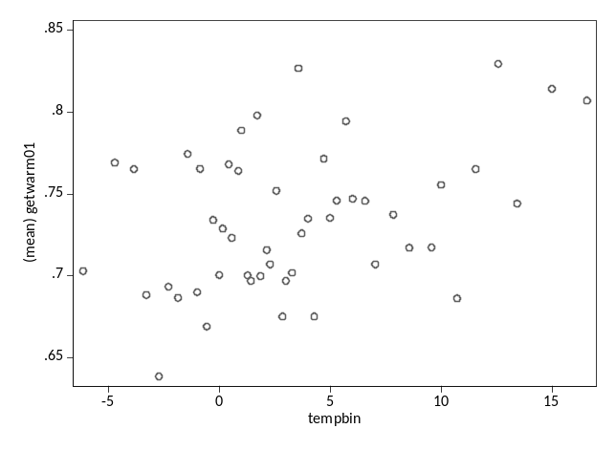

II. SUMMARIZING the Relationship NON-PARAMETRICALLY

a. Table: Summary Statistics for Y by Values of X

. table educyears, c(mean famincome median famincome sd famincom)

----------------------------------------------------------
Years of |
Education | mean(faminc~e) med(faminc~e) sd(faminc~e)
----------+-----------------------------------------------
0 | 30277.78 32500 17690.95
2.5 | 23383.33 17500 16861.47
5.5 | 25800 22500 20889.18
7.5 | 33012.9 22500 28464.15
9 | 39599.74 32500 30232.96
10 | 40429.91 32500 32337.82
11 | 41450.45 32500 33324.25
11.5 | 43551.47 45000 25684.93
12 | 43733.9 37500 28895.93
13 | 53493.88 45000 33180.55
14 | 57854.84 55000 32961.58
16 | 66617.31 67500 34944.65
18 | 75098.48 67500 32904.3
22 | 87965.12 87500 34723.64
----------------------------------------------------------

b. FIGURES (generally appropriate when X, Y or both are at interval-level or higher)

i. a BAR CHART displaying central tendencies of Y by values of X:

. graph bar (mean) famincome, over(educyears)

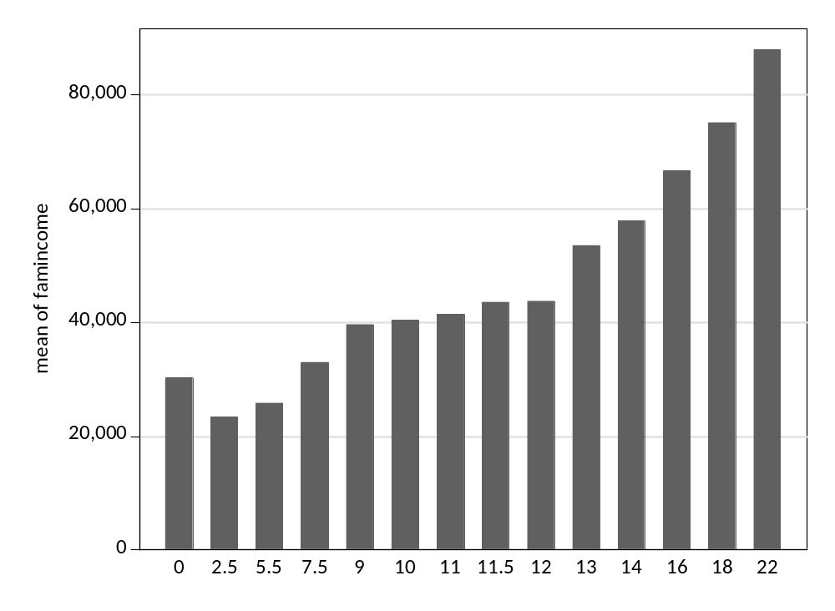

(Note: not ideal because gives false impression that intervals between bars are equally sized.)

Another way, with bar heights labeled:

. graph bar (mean) famincome, over(educ_rc) blabel(bar)

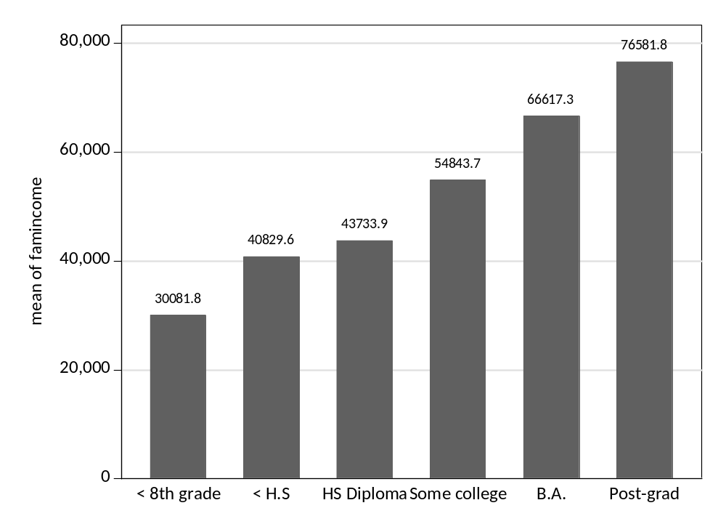

ii. SCATTERPLOT WITH SMOOTHER displaying mean of Y by values of X (both X,Y interval-level or higher):

(We’ll hold off on discussing details of how the smoother is constructed. For now, simply note that it requires very little in terms of parametric assumptions.)

. twoway (scatter famincome educyears, jitter(20) msize(tiny)) (lowess famincome educyears, clc(black) clw(thick)), legend(off)

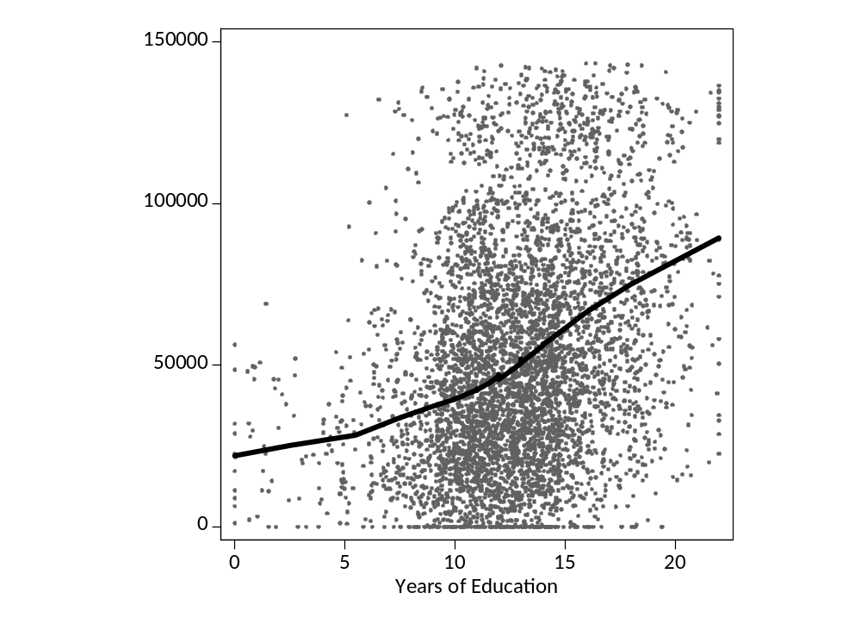

III. SUMMARIZING the relationship PARAMETRICALLY

i. The correlation coefficient

Sometimes it acts like we want it to. Very strong here, as it should be:

*generate 201 x values ranging from -100 to 100 in steps of 1:
. egen x = fill(-100/100)

*generate 201 y values equal to x plus a bit of noise:
. gen y = x +rnormal(0,5)

. scatter y x, aspect(1)

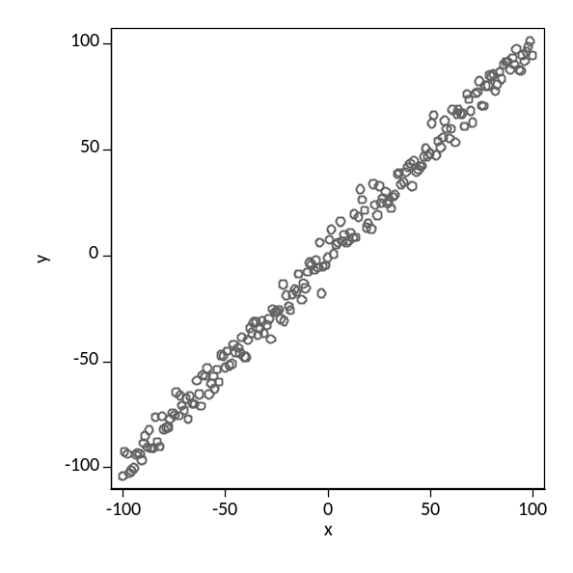
. corr y x
(obs=201)

| y x
-------------+------------------
y | 1.0000
x | 0.9963 1.0000

A little weaker here, as we would expect (and want):

*generate 201 y values equal to x plus a lot more noise:
. gen yprime = x +rnormal(0,20)

. scatter yprime x, aspect(1)

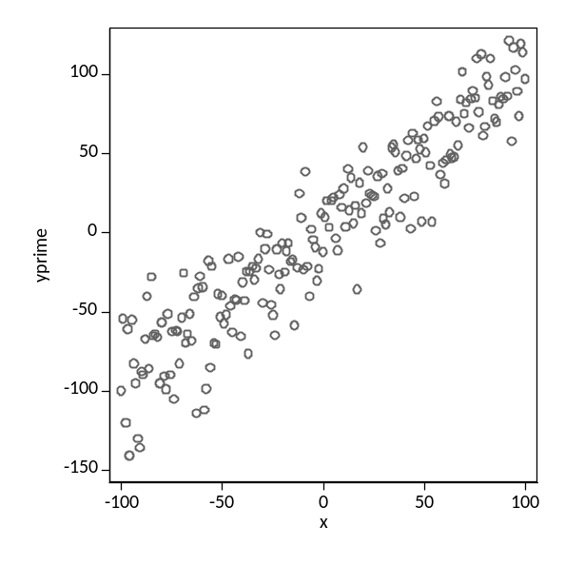

. corr yprime x
(obs=201)

| yprime x
-------------+------------------
yprime | 1.0000
x | 0.9348 1.0000

But is terrible at detecting non-linear relationships, no matter how strong:

*generate 201 y values equal to x-squared plus noise:
. gen y2 = x^2 + rnormal(0,1000)

. scatter y2 x, aspect(1)

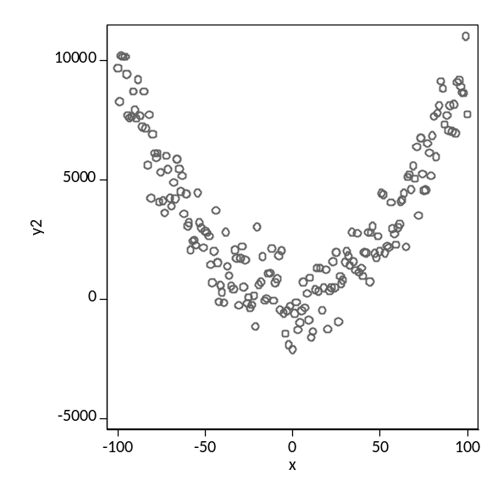

. corr y2 x
(obs=201)

| y2 x
-------------+------------------
y2 | 1.0000
x | 0.0096 1.0000

And is very sensitive to outliers. Here there is no relationship between x and y in obs 1 through 99. See how adding just one additional observation changes the correlation coefficient:

. set obs 100

. gen xdoubleprime = 33

. egen ydoubleprime = fill(50 52 54 56 58 50 52 54 56 58)

*note no relationship betw x and y among these observations;
*now let’s change obs # 100 as follows:

. replace xdoubleprime = 80 in 100
(1 real change made)

. replace ydouble =75 in 100
(1 real change made)

. list xdoubleprime ydoubleprime

...

|---------------------|
91. | 33 50 |
92. | 33 52 |
93. | 33 54 |
94. | 33 56 |
95. | 33 58 |
|---------------------|
96. | 33 50 |
97. | 33 52 |
98. | 33 54 |
99. | 33 56 |
100. | 80 75 |
|---------------------|
. scatter ydouble xdouble, xsize(3) ysize(3) xlabel(0(25)100) ylabel(0(25)100) jitter(20)
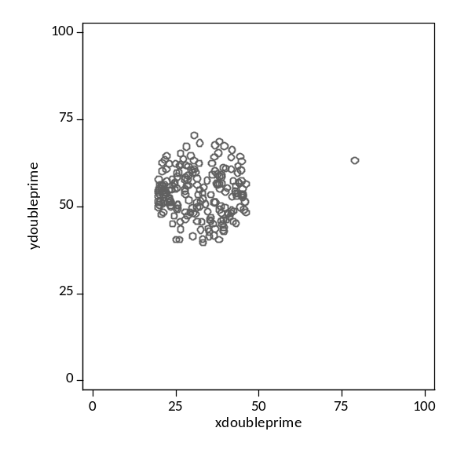

. corr y x
(obs=100)

| ydoubl~e xdoubl~e
-------------+------------------
ydoubleprime | 1.0000
xdoubleprime | 0.5988 1.0000

That’s a pretty darn high correlation, considering we have nothing but random covariation in obs 1-99!

